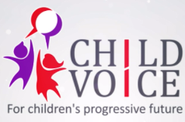
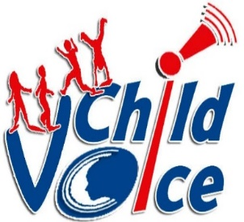
For Children’s progressive future

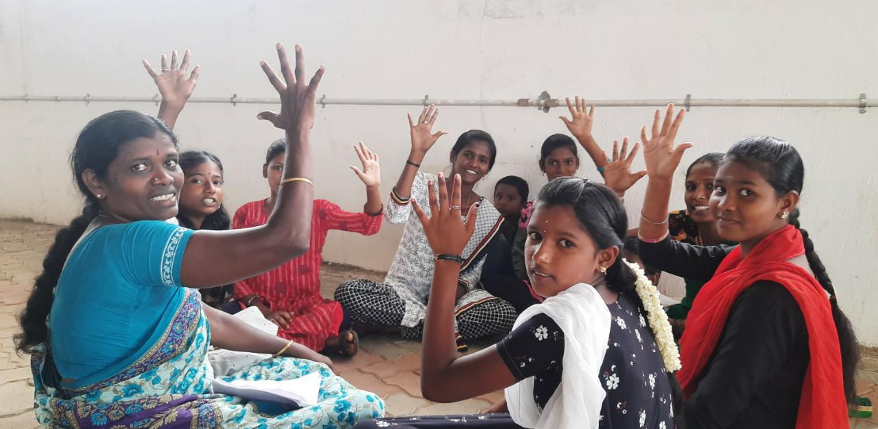

ANNUAL REPORT 2021-2022
CHILD VOICE
Dindigul District, Tamilnadu

FORWARD
Dear All,
Warm greetings from Child Voice!
We are happy to share our annual progress report with you all for the years 2021 to 2022 from the months of April to March. We have achieved our work as per the plan we had and impacted many children, women, and mill workers in our 30 working areas at Nilakottai block in Dindigul District. From the year 2021 to 2022, we have capacitated our staff team, initiated a new project with Azim Premji Foundation, and extended our project to another 10 villages in the Nilakottai block. Developed the Visibility of the Organization with the support of the Dhawani Foundation, Bangalore, updated our project events on social media and improved our staff potential. With this brief note, I would like to thank all our donors and individuals who have contributed to bringing the transformation of many vulnerable people and I also take this opportunity to thank my staff team, Panchayat President, Teachers, Like-minded NGOs and stakeholders, government departments Police, BDO office, Taluk Office, Health, Education, DLSA, TLSA for supporting to effective implementation of our projects in our target villages.

S.Annadurai
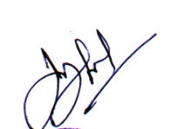
Director,
Child Voice

CHILD VOICE
Child-based welfare interventions for holistic children development
Child Voice is a non-profit, non-governmental organization working towards the sustainable development of children and their families. A UK-based volunteer, who witnessed the pathetic condition of tribal children living in the Kodaikanal region, became the main reason behind the existence of this organization. He seeded the necessity for an organization that would work exclusively for the welfare of the children. Ever since then, our organization became a voice for children living in absolute poverty and negligence. We initiated our activities by providing healthcare facilities for children living in tribal areas. Later on, we expanded our activities and supported many children by giving them access to education, and healthcare facilities, developing their skills, and awareness programmes, and rescuing them from child marriage, child labour and bonded labour practices. Through our process of rescuing and rehabilitating children, we realised that their parents need sustainable livelihood opportunities to support their children further. So, we provided livelihood support for the tribal community and Entrepreneur Development Program Support for the target children's families for alternative income. We financially strengthen the families of children so that they are not caught up in the vicious circle of poverty. Our target programmes have benefitted a lot of children and their families in achieving a better standard of living.
Vision
A progressive Society involving, Promoting and safeguarding the rights of Children.
Mission
- To empower underprivileged children and to ascertain their rights, particularly the protection and participation rights.
- To establish sustainable communities that priorities child rights.
- To bring policy-level changes for the implementation of children’s rights through advocacy and networking.

Objectives
- To identify and map school dropout children, runaway children, street children, children at risk and child labourers in the operational areas of Dindigul, Palani and Kodaikanal.
- To protect school dropout children, runaway children, street children and child labours from economic exploitation and protect them against all forms of abuse and discrimination.
- To facilitate and create opportunities for their skill development and economic independence by enhancing them through capacity-building programs enabling them to be a dignified and resourceful citizen.
- To equip the children with life skills for living in harmony with other children and to facilitate their learning opportunities and enhance their capacity towards increasing future employment opportunities.
- To create opportunities for children to showcase their talent and identify and promote leadership qualities and enable increased child participation through the collective forum.
- To empower children sangams and federation to identify child rights violations and enable them to address the issue by themselves and to ascertain their rights.
- To promote gender equity and equality in schools and communities.
- To join hands with civil society organizations in campaigns and solidarity actions for influencing policy level changes.
- To promote community ownership in operational areas ensuring child protection.
- To establish Child Voice as a resource organization in the field of child rights and effectively carry out advocacy and lobbying both at micro and macro level jobs.

Policies
- Administration policy
- Anti-corruption policy
- Child Protection policy
- Safeguarding policy
- Finance policy
- Governance policy
- Whistleblowing policy
Child Voice Board of Trustees
Mr A. Henry sahayaraj - Founder Trustee
Mr S. Annadurai - Managing Trustee
Mr P.Anand - Finance Trustee
Mrs S. Subbuthai - Trustee
Mrs.V. Aarthi - Trustee
Child Voice Office Team
S. Annadurai - Project Director
K. Vignesh - Programme Manager
R. Manahoharan - Finanace Manager
H.Vanitha Priya - Fundraising Manager
V. Sivanagajothi - Field Co-ordinator
T. Alagurani - Field Co-ordinator
A.Mary Jenifer - Field Co-ordinator
S.Saratha - Field Co-ordinator
G.Jenifer Mary -Project coordinator, HRF Project
J.Chellapandiyammal -Library Coordinator, Rejuvenate India Movement

Child Voice Field Team
30 Facilitators are working in 30 working villages under Nilakottai Block in Dindigul District, Tamilnadu .
Highlights of The Programs:
- 118 Vaccination Camps / 6 Fever Camps are conducted and covered 6767 Beneficiaries in 30 Villages.
- 13 Children and 7 women are supported through Counselling and Mental Health Services.
- 5 School dropout children are identified and enrolled in Schools.
- 1084 Children are supported through Community Resource Centre activities.
- 713 girls are supported through 50 AAG group meetings /SMS Priya Weekly Campaign and Discussion.
- 477 Boys are supported through 30 ABG group meetings.
- 577 members are supported through 30 CSG group meetings.
- 357 members are supported through 30 WSG meetings.
- 21 members are supported through 2 Mill-based WSG meetings.
- 1107 members are supported through 88 SHG group meetings.
- 90 CSG members are trained on the CSG federation at the Block level.
- 1 Block level Community Support Group Federation Initiated.
- 13 Village Panchayat VLCPCs are activated.
- 10,169 members are supported to receive social security schemes out of this,8839 are E Sharam Cards.
- 1 Mill worker enrolled in 3 months Vocational Course on GST filing.
- 74 PRI members/Village Volunteers trained on registration of migrant data at the Panchayat level.
- 11 mill workers are trained on Internal Committee Process and POSH Act 2013.
- 3525 members are involved in the observation of important days.
- 1 policy level change has been brought by Community Support Group members at the District level.

Activities
Community Resource Centres
Child Voice runs Community Resource Centres for vulnerable children in 30 working villages in Nilakottai Block. This CRC acts as a resource centre for children coming from illiterate backgrounds, apart from this, it also acts as a centre where people looking to avail government schemes are helped in the process. A total of 1033 (550 girls and 483 boys) Children are benefitted through our CRC..
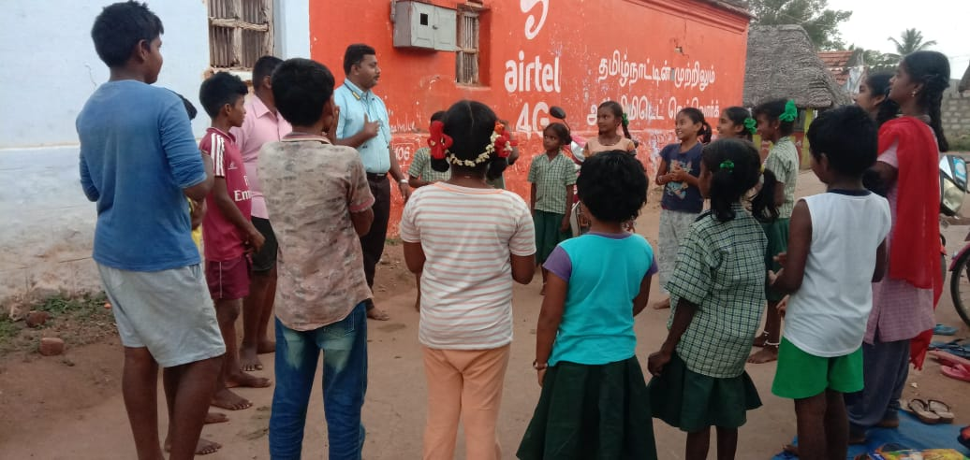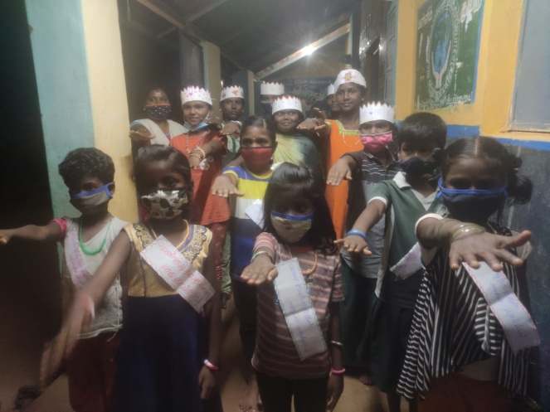
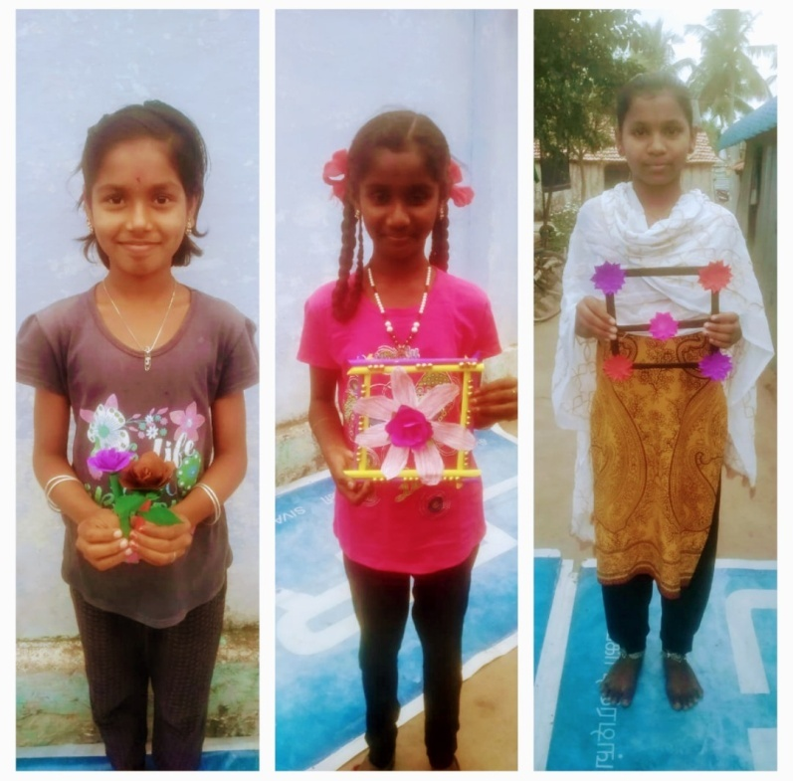

Community Groups
Adolescent Girls Group & Adolescent Boys Group
50 Adolescent Action Group (AAG) and 30 Adolescent Boys Groups (ABG) are formed in 30 villages in the Nilakottai block where Child Voice is operating. A total of 706 adolescent girls are members of the Adolescent Action Group, and 476 adolescent boys are members of the Adolescent boy’s Group.
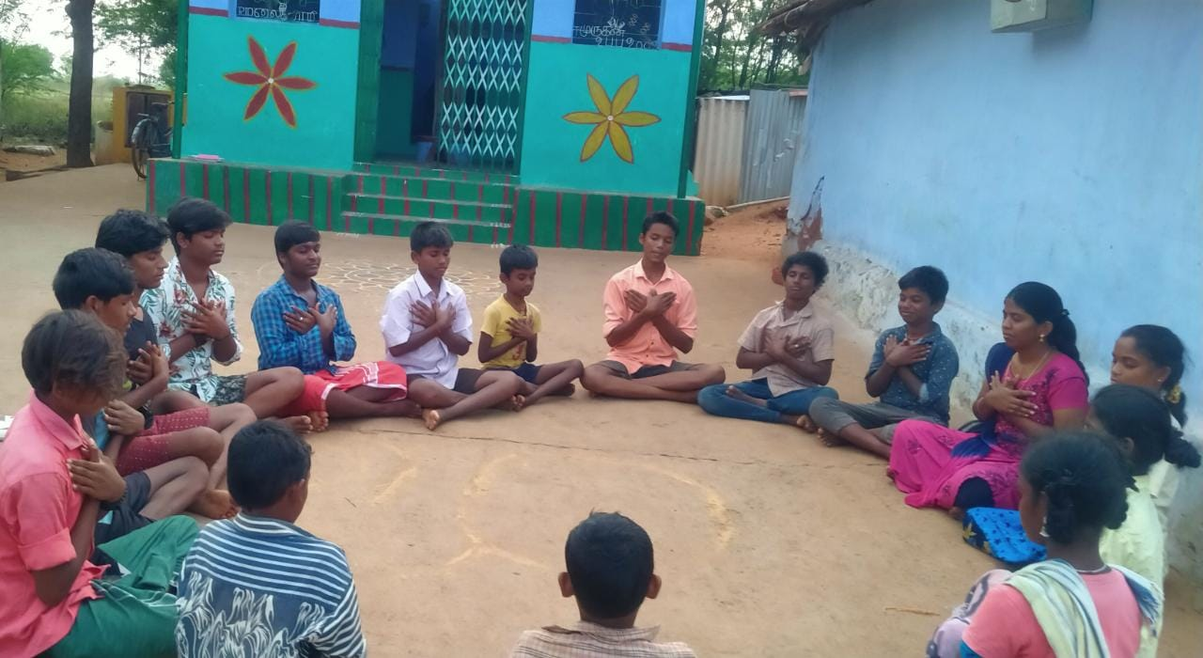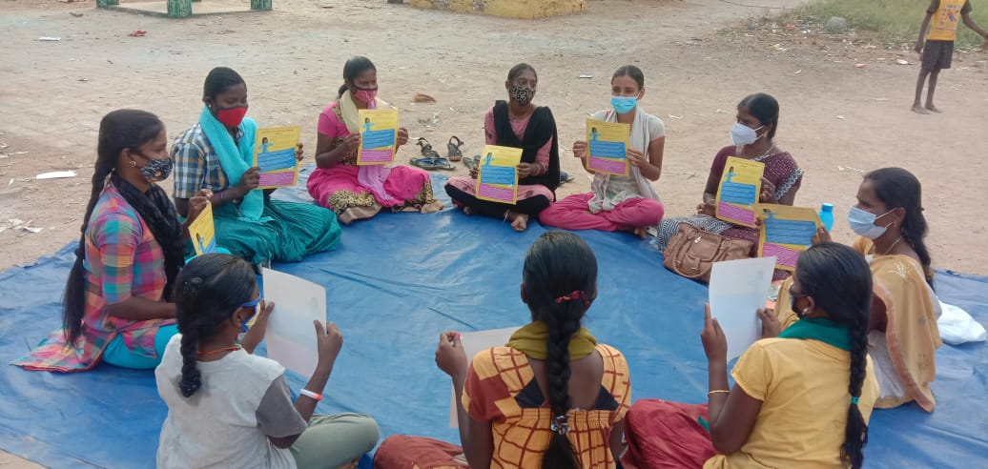
Adolescent action group (AAG) members from one village to another village visited each other and interacted among them. It was a great exposure visit to the AAG group’s members for their knowledge sharing and knowing of best practices. The purpose of the visit was to discuss the effective use of Child Line Number 1098 to stop child marriage, lessons learnt through Unnai Ne Arivai Book, Major challenges faced by adolescent action group members during the lockdown pandemic situations, Situational analysis of the school dropout especially talked about the practice of seasonal child labour system in the villages due to school shut down in lockdown days, Online classes impacts and addiction of mobile phone by peer group members, knowledge shared about the POSCO act, Importance of Nutrition food, Safe hygiene practice during mensuration time and recalling of Call me Priya (Film Based Curriculum Book ). This meeting was very insightful and gave the confidence all the AAG members to become very confident to work in a group work towards the empowerment of adolescent girls to protect them from risky situations. As a result of these interaction meetings, AAG members has become a member of the VLCPC of Child Voice working village at Nilakottai Block.
9 AAG girls and women survivors were admitted in Skill training courses (3 months Typewriting,2 months ANM nursing courses) in Pottychetty patty and Kokkupatty Villages with the support of Facilitators.12 students were admitted to schools and Colleges for their higher education from Kalkottai, Kattunayakanpatty, Muthalapuram villages.
Totally 939 beneficiaries applied for various social security schemes such as Aadhar correction, Voter id, Birth certificate, Death certificate, Income certificate, Community certificate, and Rs.12/rs.330 Insurance schemes, House Patta, OAP, Labor welfare card, first-generation graduation card, E-Shram card, and Nativity certificate, out of which 372 people received the schemes.
Counselling service was provided to 9community people who were mentally distributed in the village of Sanadalarpuram, Avaiyampaty and Sangalpatty due to girl missing in their families.
9 New SHGs were formed with 120 members in 6 Villages (Ethilodu, Maniyakaranpatty, Sangalpatty, Utchanampatty, Pudukkottai, Avaiyampatty).
1 worker support group was formed in Intaliya Knitwears Pvt Ltd Company at Vadipaty Jawli park.
Legal cases were assisted for arresting and filing the FIR in the police station with regard to the girl missing.
Community Support Group
The community support group is a forum of people formed to address the issues such as child marriage, violence against women with the help of Child Line 1098, and emergency helpline services for women. We approach the concerned families and give counselling to help them out of their problems. A total of 462 members are in 30 community groups in 30 villages of Nilakottai Block.

Workers support Group
Child Voice formed 30 workers’ support groups to help women and adolescent girls working in the textile and garment industries. Internal Compliance Committee is formed in the companies to address sexual harassment in the workplace. Totally,358 members have joined this group.
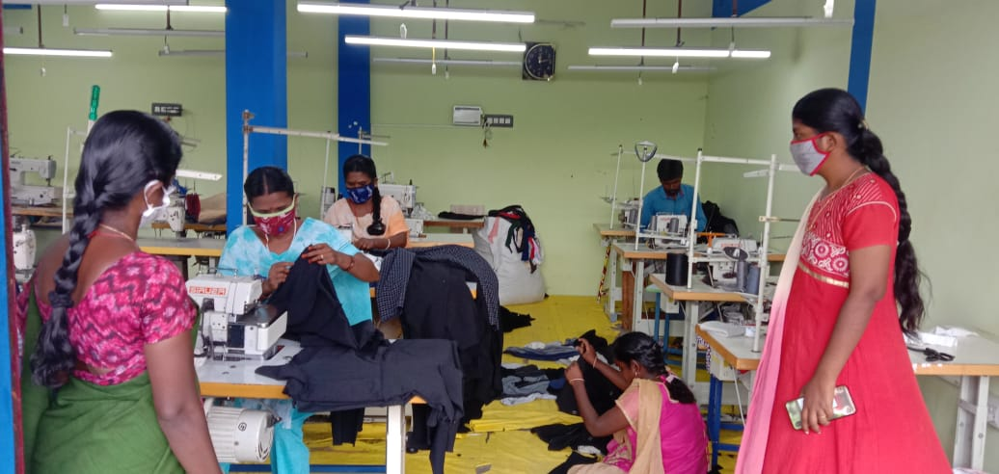
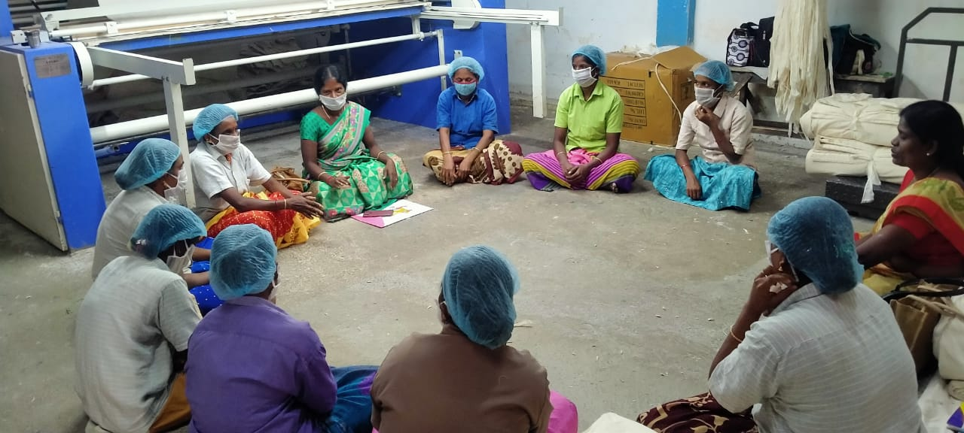
CRE Clubs
Child Voice Operates 5 CRE Clubs in Nilakottai Block and 2 CRE Clubs in Kodaikanal Block
Sl.No | Name of the Club | Members of the Club | Facilitator
1 | Veelinayakanpatty | 20 | G.Ramajeyam
2 | Thoppupatty | 14 | V.Pothumai
3 | Kamatchipuram | 16 | R.Murugeshwari
4 | Noothalapuram | 14 | Santhya
5 | Maniyakaranpatty | 14 | Rajalakshmi

Grama Panchayat Village Libraries
Child-friendly gram panchayat libraries were initiated in 5 panchayats (Veelinayakanpatty, Musuvanathu, Mettupatty, Kullichettypatty and Nariyuthu) at Nilakottai Block. A total of 1325 library books worth Rs.35,075 were supported by Rejuvenate India movement to CRC
centres in five panchayats.
Child-friendly gram panchayat libraries were initiated in 5 panchayats (Veelinayakanpatty, Musuvanathu, Mettupatty, Kullichettypatty and Nariyuthu) at Nilakottai Block. Totally 1325 library books worth Rs.35,075 were supported by Rejuvenate India movement to CRC centres in five panchayats. This Child-friendly library will be an added advantage to improving the knowledge of CRC students covered by five panchayats. As part of this programme career guidance also will be given to students who are eligible to go to higher students. In addition, parenting counselling also will be offered. In all five panchayats libraries were opened by Village Panchayat Presidents.
VLCPC
VLCPC's main objective is to protect and promote its rights. Regular meetings are conducted in 5 Panchayats (Musuvanthu, Kullichettipatty, Veelinayakanpatty, Kullalakundu, Nuthalapuram) in the Nilakottai block to strengthen the functioning of VLCPC. Facilitators and CSG members were added to VLCPC to represent our organizations. In this particular year, a total of 182 members participated in this VLCPC meeting.
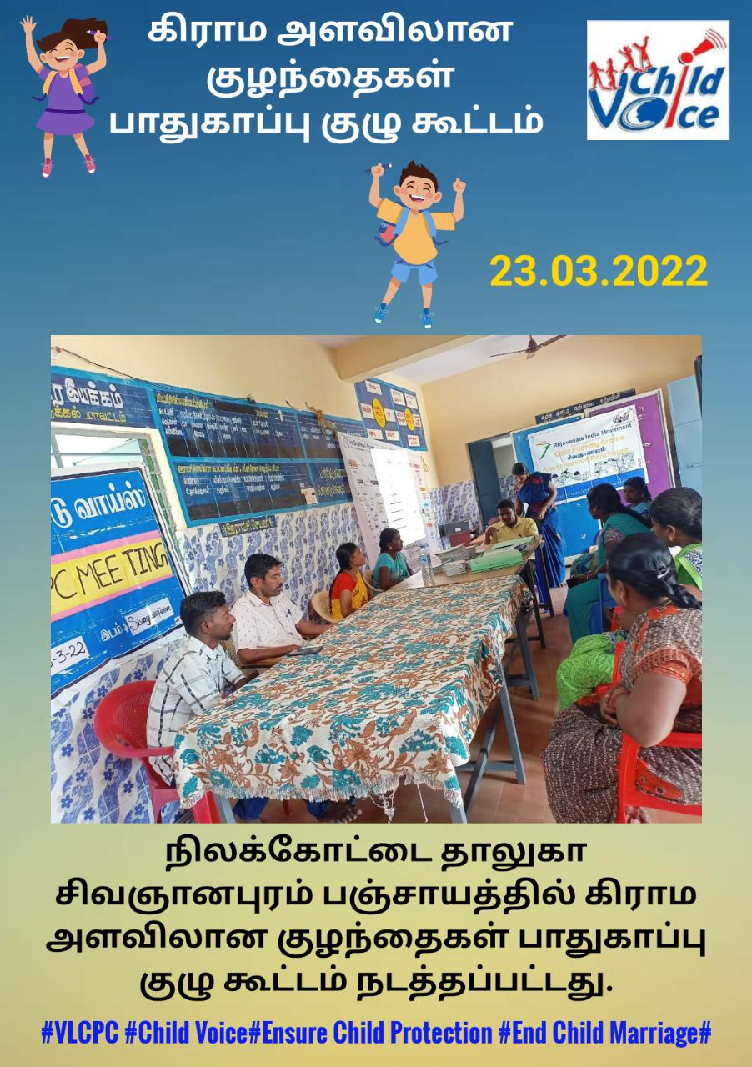
It has also joined hands with District Legal Service Authority, Taluk Legal Service Authority, Department of Police, Department of Integrated Child Development, Department of School Education and Likeminded grass-root NGOs and created a mass awareness among on public on the prevention of Bonded Labor and Child Labor system, Human Trafficking in the Villages in and around Nilakottai Block.
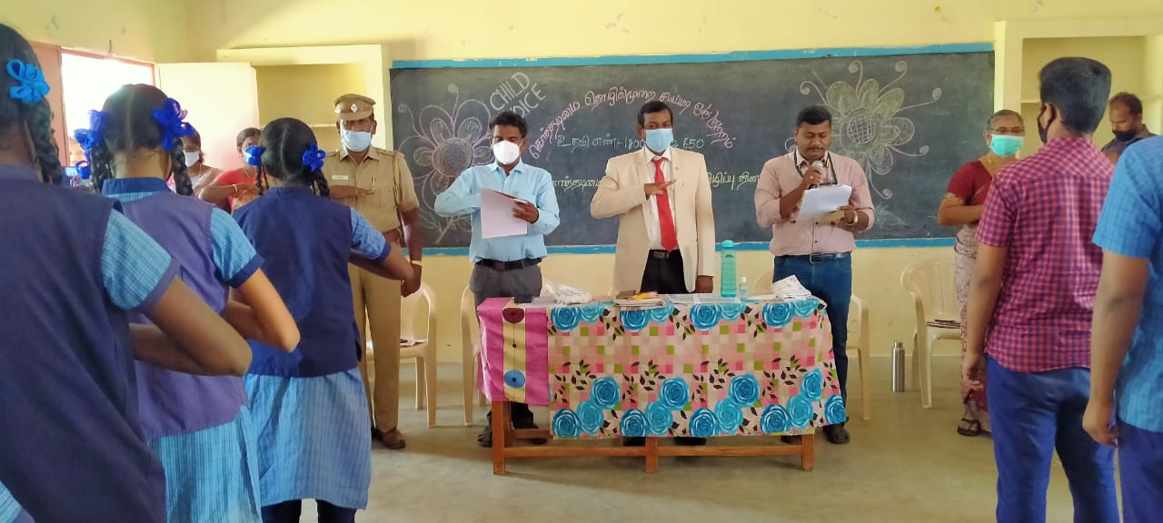
VLCPC meeting was conducted in Two Panchayats Veelinayakanpatty and Kullalakundu and the issues of Children were discussed in the meeting, followed by placing the visibility board at the common places in the panchayat to empower the community to protect the children at risk was planned. Totally 26 members along with the general public in Veelinayakanpatty panchayat and 14 members in Kullallakundu panchayat were VLCPCs.
In collaboration with ICDS (Integrated Child Development Schemes of Nilakottai Block, an Orientation on Life skills and career guidance program was provided to Adolescent Girls who are studying in schools and colleges. Annadurai, the Project Director and Mr, Vignesh, the Program Manager were the key resource persons to conducting this training and reached out to 250 adolescent girls from 4 schools and 1 college.
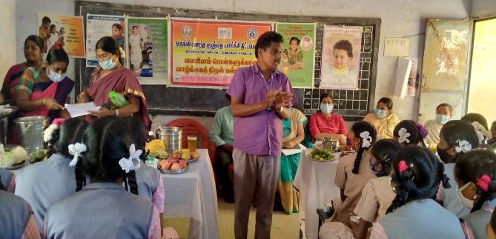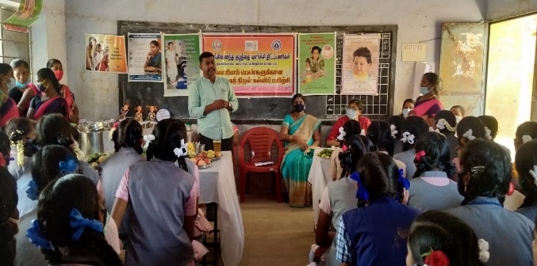
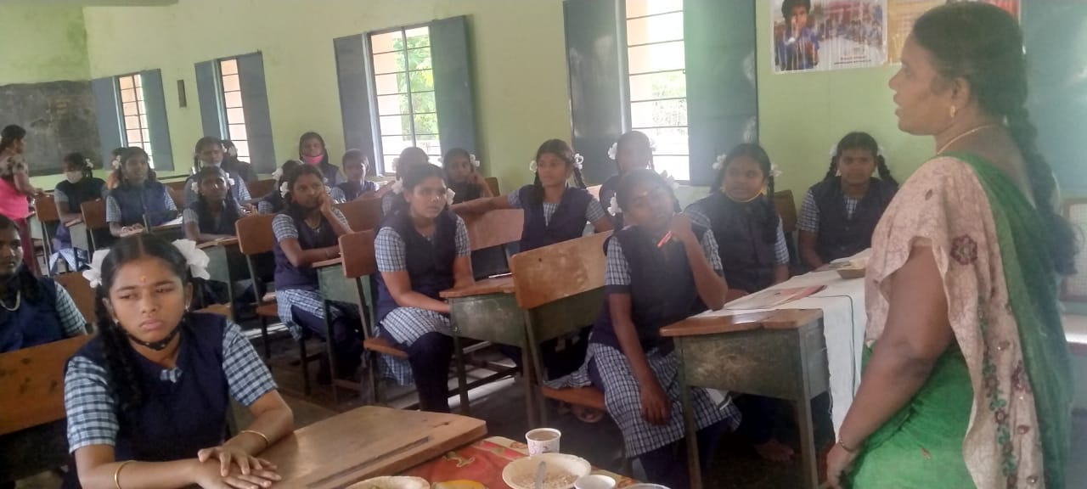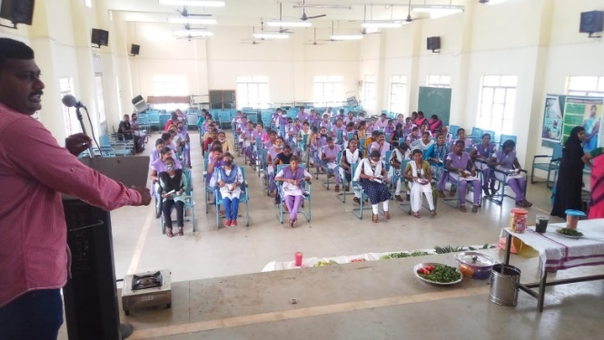
SMC
Child Voice has Representation in School Management Committees in Schools in 30 villages of Nilakottai Block. Child Voice staff members enrolled their names in school management committees to support the school’s development.
SMC meetings were organized in Villages Avaiyampatty, Veelinayakanpatty, Musuvanathu, Pillayarnatham, Sivananpuram, Viralipatty, Kokkupatty and Facilitators from Child Voice Nilakottai Project represented in the meeting and discussed the identification of school dropouts, enrolling them back to schools and reducing the child marriages.

Skill Training
Sl.No | Total no of Beneficiary | Course | Duration

Internal compliance committee
Child Voice formed an Internal Complaints Committee in three agreements companies - two companies in Vadipatty and one in Vilathur, Madurai. This committee was arranged to prevent sexual harassment at the workplace, and also to train staff members on POSH Act. Quarterly meetings of ICC were organised by Child Voice in these three companies. A regular follow-up visit was carried out by the staff members of Child Voice in these companies with regard to counselling, training, meetings, and based on the need raised by the company for the benefit of staff members. All the meetings were done with the support of the Management of the Company and staff members. Internal Committee meetings in Garment factories had been conducted and orientation was given to IC members on the Prevention and prohibition of Sexual harassment at Workplaces. Worker’s Support had been formed.
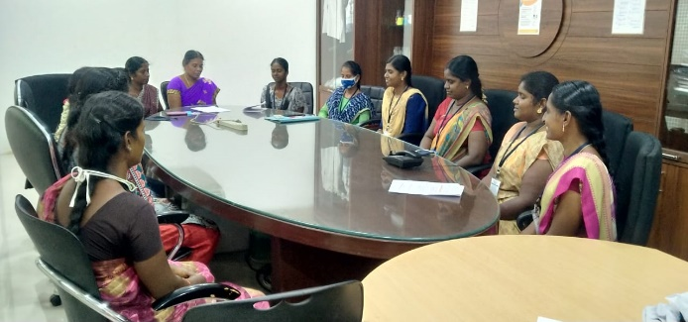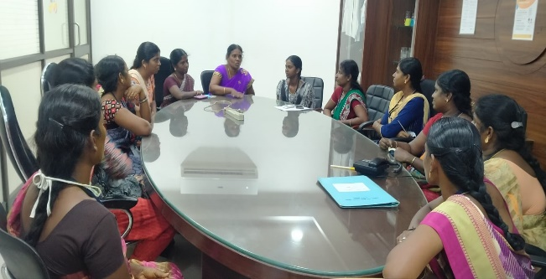

Health Camps
Child Voice Nilakottai project organized a Vaccination camp and Covid Test Camp with local panchayats and the Health Department to reach out to the community people in 30 working villages in Nilakottai Block to prevent the spread the Corona diseases in the community. Totally 7 vaccination camps including 4 Covid Test camps conducted at Thoppupatty, Kokkupatty, Palam patty, Kattunayakanpatty, Kundalapatty, Sirunayakanpatty and Kullalakundu panchayat. Out of these Vaccination camps and Covid Test camps, 2618 community people benefited. This vaccination camp was organized in the villages in presence of the Panchayat president, Primary health centre doctors, Health inspectors and Village health nurses.
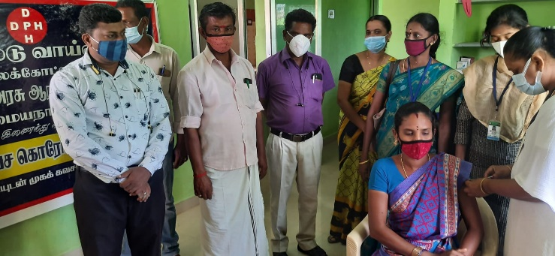
Observation of Important days
Important days were observed in working villages by AAG, ABG, CSG and workers support groups from April 2021 to March 2022. The following important days were observed in villages
April 2021 to March 2022
1.5.2021-International Labour Day
5.5.2021-World hand wash day
12.6.2021-Anti Child Labour Day
21.6.2021-International yoga day
Anti-human trafficking day -30th July 2021
Anti-human trafficking day observed in office. Mr Murugan, Deputy super ident of Police, and Mrs., Baby, Inspector of Nilakottai came to this event and released the posters and bit notices against Human trafficking. Like-minded local NGO heads also participated in this event. This notice and posters were distributed to people in 30 working villages of the Child Voice Nialkottai project.
Independence Day -15th August 2021
International Day of Democracy -15th September 2021
Campaign against bonded labour system -3rd October 2021
Campaign against bonded labour system rally was conducted on 2nd October 2021 in Kullakaukudu panchayat. Mr Bharathi Raja, DLSA secretary, Mrs.Yasothai, and Kullakundu panchayat president were the chief guest at this event and gave a keynote address to the public. Inspector Shanmugalakshmi, Ammaiyanayakanur police stations, Project director Annadurai, Advocates Parthipan, Raja, Counsellor Lalitha Manikandan, Field co ordinator, facilitators were taking part in this event and participated in the rally.

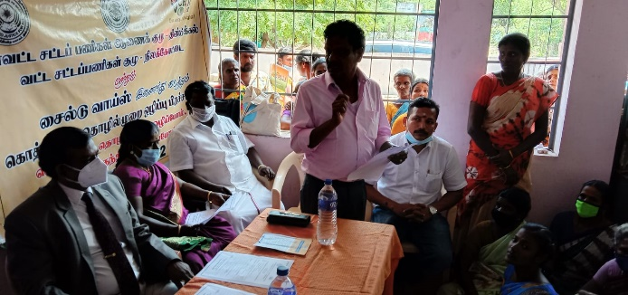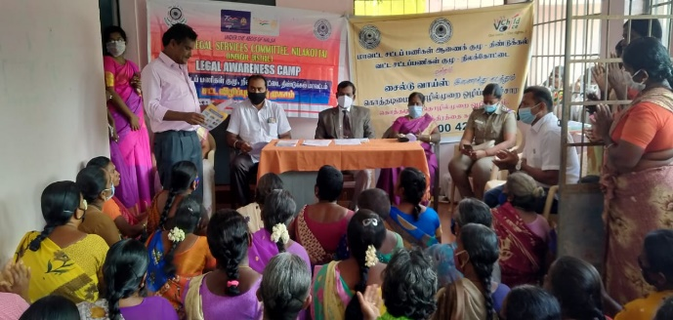
Totally 1547 Community people participated in these important days observed in the villages by AAG, ABG and CSG members along with our staff members.
Internship programme for college students
Sl.No | Name | Department | College | Duration
1 | R,Mugambikai | BSW III year | Anaugraha Institute of Social Sciences | 15th September 2021 to 15th December 2021.
2 | Emijersal
3 | Mercy J.Rock
4 | A.Samboorna Illavarasi | MSW II Year | Tamilnadu Open university | 1st Otober 2021 to 31st December 2022
5 | S.Aswitha | Women studies | Mother Theresa University, Department of Women Studies, Pallapatty. | 27th December 2021 to 31st December 2021
6 | M.Bariji | Women studies | Mother Theresa University, Department of Women Studies, Pallapatty. | 27th December 2021 to 31st December 2021
7 | S.Pradeepa | Women studies | Mother Theresa University, Department of Women Studies, Pallapatty. | 27th December 2021 to 31st December 2021
8 | G.Manimegalai | Women studies | Mother Theresa University, Department of Women Studies, Pallapatty. | 27th December 2021 to 31st December 2021
9 | M.Swathi | BSW II year | Anaugraha Institute of Social Sciences | 2nd March to 4th May 2022
10 | U.Dharani | BSW | Anaugraha Institute of Social Sciences | 2nd March to 4th May 2022
11 | S.Amirtha | BSW | Anaugraha Institute of Social Sciences | 2nd March to 4th May 2022
12 | F.Jenitha | MSW | Anaugraha Institute of Social Sciences | 7th March to 2nd April 2022

Staff Meetings and Training
Four Elected PRI members of our working villages had been trained and capacitated on the Role and Responsibilities of Ward members, Panchayat President and how effectively they play a vital role in improving their panchayat activities with the available local resources and with provided funds by the government.
Programme Manager Vignesh, Selected FCOS Sivanagajothi, Alagu rani, Mary Jenifer, Saratha and Facilitators Sumathi and Saritha were trained to form Workers Support Group in the villages as well as in the mills and strengthen the groups to identify and address the issues of labours and availing their benefits with the collective bargaining /negotiation with mill management.

Media clippings
